BOC API Document
Awaiting Vendor Quote
“Add Vendor”:
- /api/v1.0/repairRequest/AssignVendor

- “/api/v1.0/repairRequest/AssignVendor”
Open “Front End” codebase”:
Search the API in “restURI.ts” file:
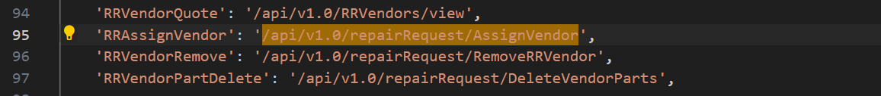
Copy: “RRAssignVendor” to search in frontend.
Open “Back End” codebase:
Open “repairrequest.routes.js”,
“Right” click on “RR.AssignVendor” in line 24, click “Go to Definition”, it shows the code in “repairrequest.controller.js”,
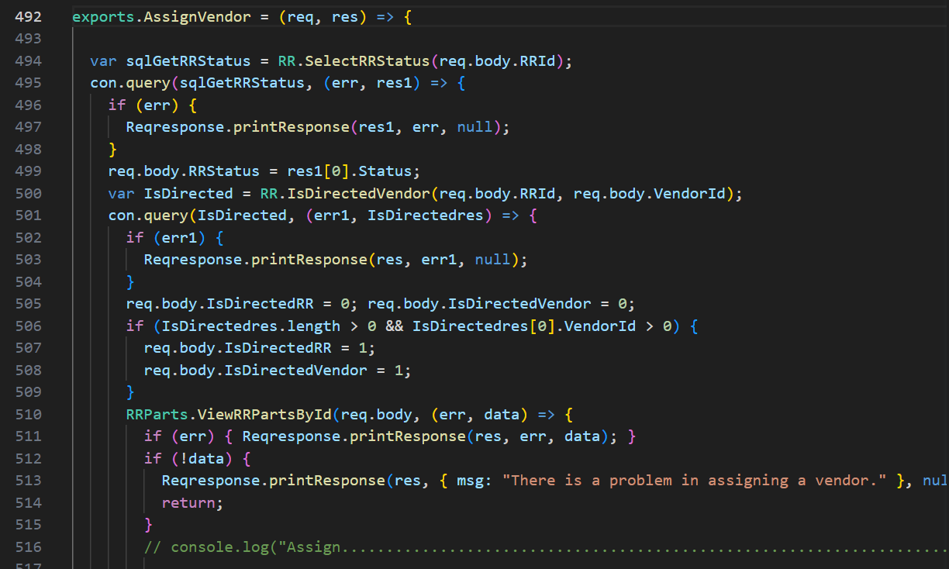and so on.
“Right” click on “SelectRRStatus” in line 494, click “Go to Definition”, it shows its “SQL” codebase in “repair.request.model.js” in line 3390,
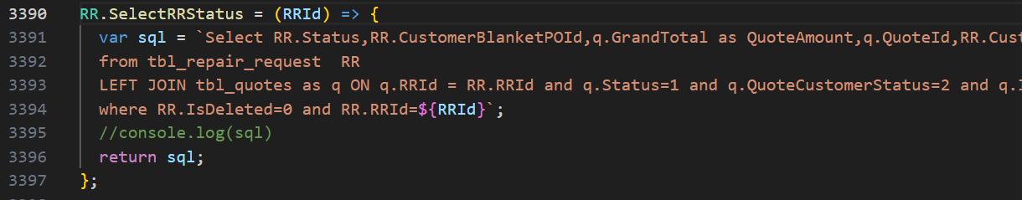
“Right” click on “IsDirectedVendor” in line 500, click “Go to Definition”, it shows its “SQL” codebase in “repair.request.model.js” in line 3399,
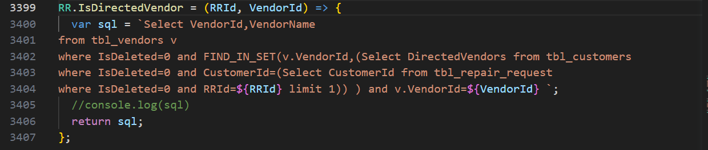
“Right” click on “ViewRRPartsById” in line 510, click “Go to Definition”, it shows its “SQL” codebase in “repair.request.model.js” in line 211,
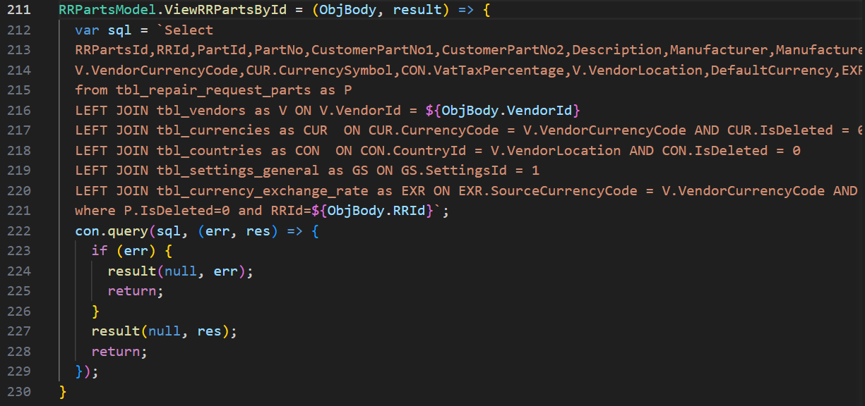
“Right” click on “CreateRRVendors” in line 549, click “Go to Definition”, it shows its “SQL” codebase in “repair.request.model.js” in line 56,
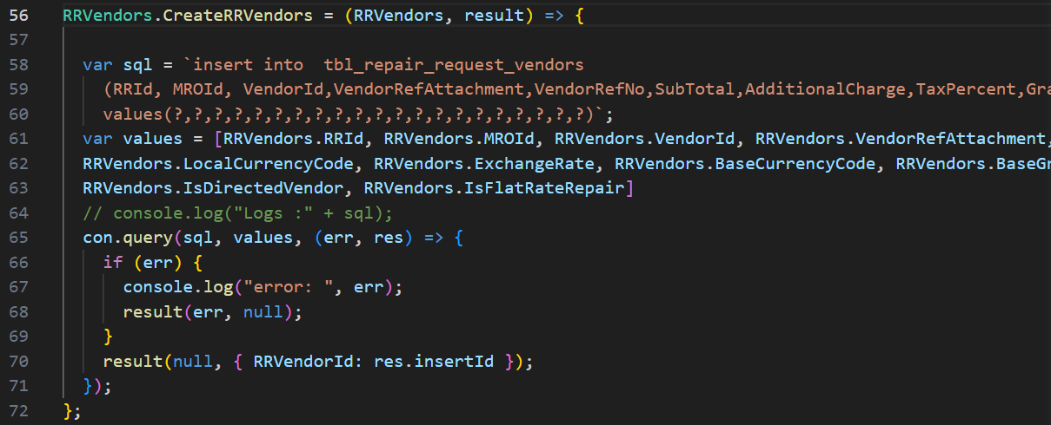

“Lock vendor shipping address”:
- /api/v1.0/address/list
- /api/v1.0/RRVendors/LockVendorShipAddr

- “/api/v1.0/address/list”: Repeated
- “/api/v1.0/RRVendors/LockVendorShipAddr”
Open “Front End” codebase”:
Search the API in “restURI.ts” file:
Copy: “LockVendorShipAddr” to search in frontend.
Open “Back End” codebase:
Open “repair.request.vendors.routes.js”,
“Right” click on “RRVendors.LockVendorShipAddr” in line 14, click “Go to Definition”, it shows the code in “repair.request.vendors.controller.js”,
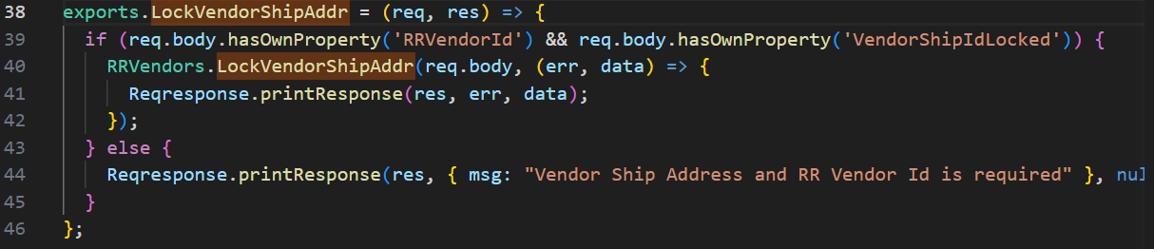
“Right” click on “LockVendorShipAddr” in line 40, click “Go to Definition”, it shows its “SQL” codebase in “repair.request.vendors.model.js” in line 287,
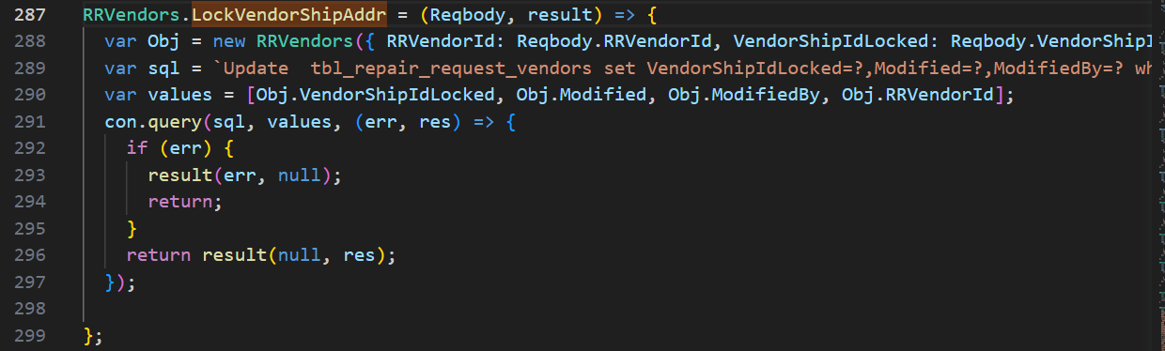

“Save”:
- /api/v1.0/notification/getLatest
- /api/v1.0/repairRequest/WorkchainMyTaskCount
- /api/v1.0/ecommerce/product/cartCount
- /api/v1.0/country/list
- /api/v1.0/repairRequest/view
- /users/getAllActiveAdmin
- /api/v1.0/RRSubStatus/dropdown
- /api/v1.0/currencyExchangeRate/exchange

- “/api/v1.0/notification/getLatest”: Repeated
- “/api/v1.0/repairRequest/WorkchainMyTaskCount”: Repeated
- “/api/v1.0/ecommerce/product/cartCount”: Repeated
- “/api/v1.0/country/list”: Repeated
- “/api/v1.0/repairRequest/view”: Repeated
- “/users/getAllActiveAdmin”: Repeated
- “/api/v1.0/RRSubStatus/dropdown”: Repeated
- “/api/v1.0/currencyExchangeRate/exchange”: Repeated

